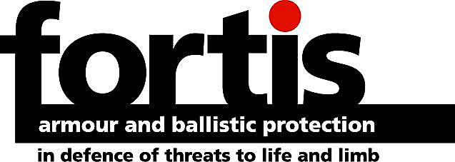 | 
T W Kempton (Corporate Clothing) Ltd
Byford Road, LEICESTER LE4 0DG
t : 00 44 (0) 116 261 0001
f : 00 44 (0) 116 261 1186
e : smartin@twkempton.co.uk
w : www.twkempton.co.uk

Body Armour Measurement Chart
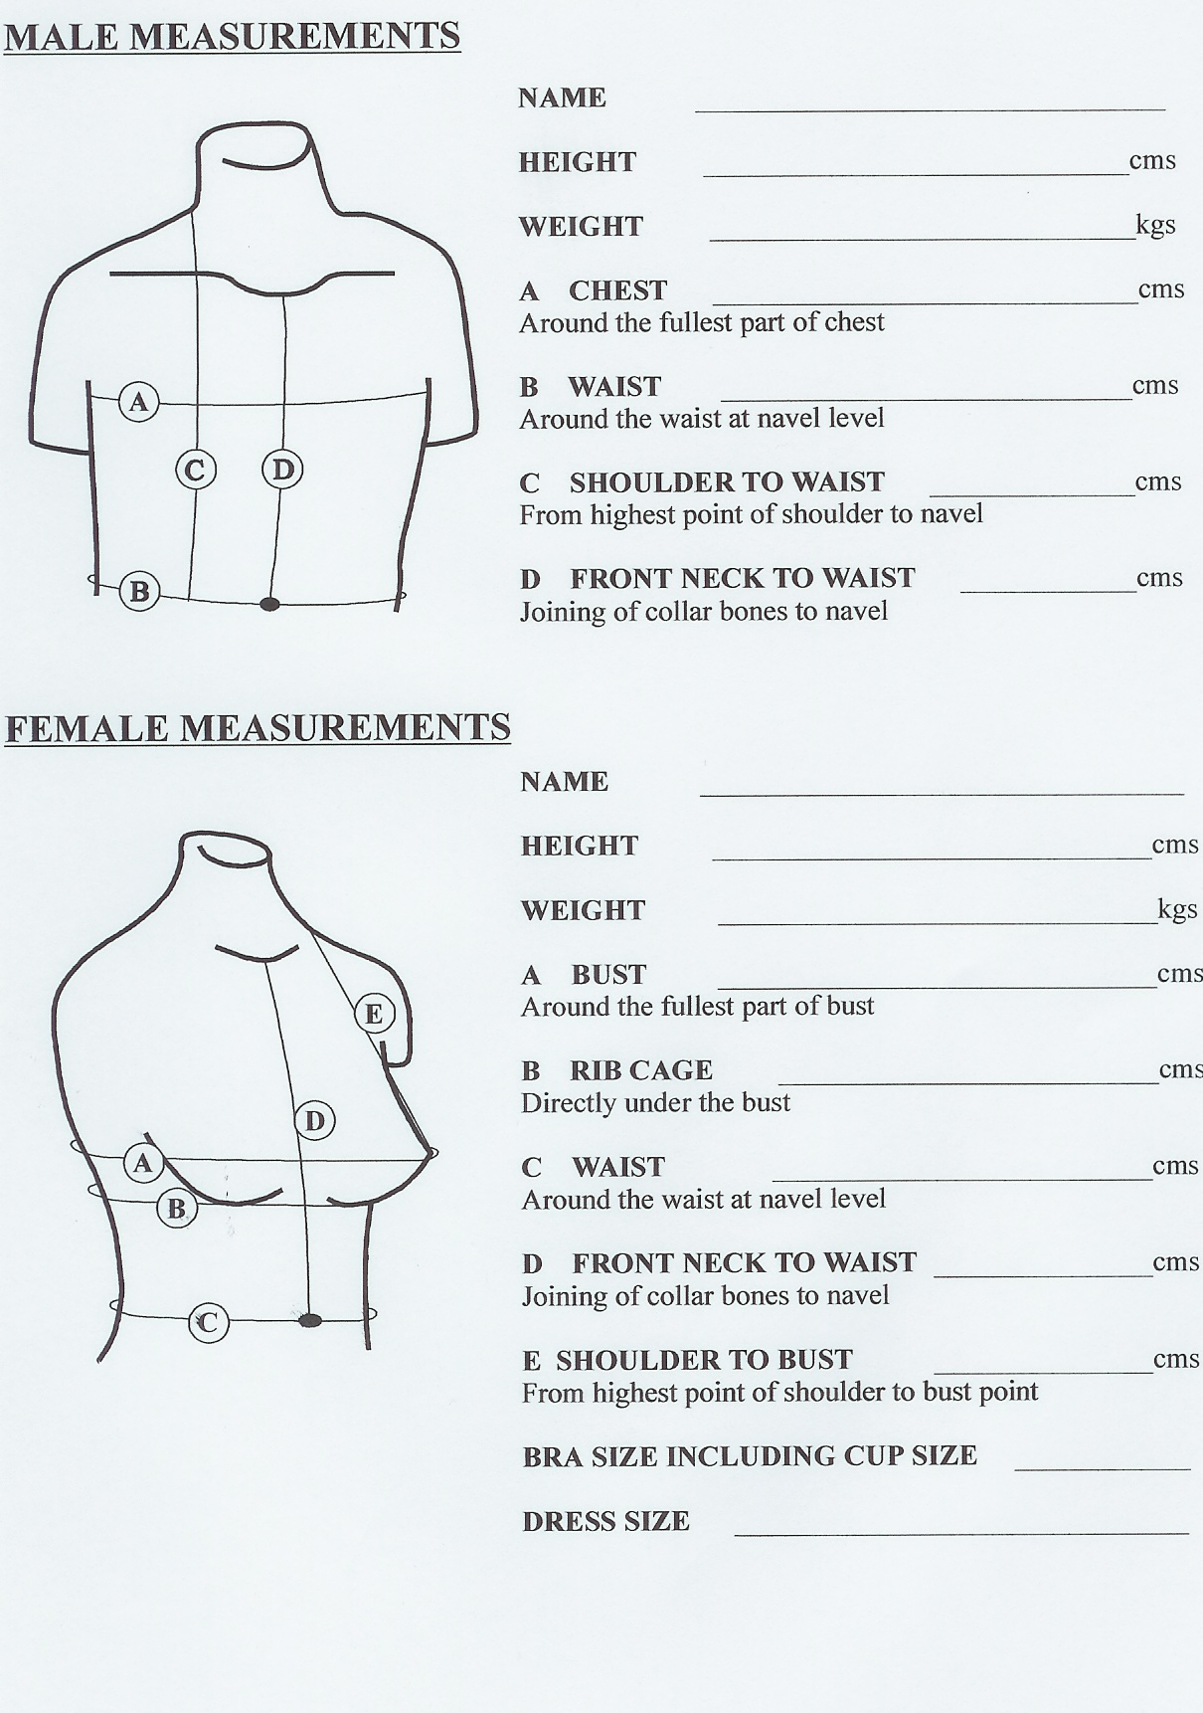
The main measurements we require are:

HEIGHT
CHEST
WAIST

(& for female wearers, bust cup size if larger than a ‘C’ cup fitting)

A Chest measurement:
We require the maximum reading whilst breathing in & holding the breath.

B Waist measurement:
Take this measurement whilst standing & seated. When seated, we need the widest measurement. This measurement is not your trouser size.

C Shoulder to waist:
From the nape to the navel. Take this measurement standing.

D Sternum to waist:
The sternum is the point where the bottom of a tie knot usually rests. Take this measurement both seated & standing.

